International Association of Charities
AIC UK - Part of the world wide Vincentian Family

ACTING TOGETHER – AGAINST ALL FORMS OF POVERTY

AIC UK is part of the 150,000 strong International group of, primarily, women whose spirituality is rooted in Vincentian tradition. Begun in 1617 by St Vincent De Paul, the Confraternities of lay volunteers help the disadvantaged in society. Groups became the Ladies of Charity – a name that many countries still use today under the AIC umbrella. Groups in ABBEY WOOD, BEXLEY, DARLINGTON, GLASGOW, MILL HILL AND PECKHAM.

Contact Dee Mansi, UK President - deemansi@hotmail.com

AIC UK NEWLETTER AUGUST 2015
AIC Reflection Summer 2015
Your Final Destination
These summer months are marked by time off work, a break from our usual routine, a chance to see more of our friends and family. Many of us will find ourselves traveling near and far.
Vincent and Louise were no strangers to travel as they established and maintained a network of charitable activities all over France. We can read Louise’s sage advice to young sisters on how to maintain their holy modesty when sharing accommodation with strangers….and even men! We recall Vincent’s incident when he was unseated from his horse… his injured leg never fully recovered.

So let us pray for one another’s safety at this time of increased travelling, and pray for all who travel. We remember with horror, the people on holiday in Tunisia, killed by a terrorist. We think too of the hundreds of refugees trying to reach our shores, and the many families losing their lives in the process. Did Vincent himself make this same treacherous journey across the Mediterranean in his escape from slavery? As Vincentian women of the Gospel we are called to tend to the outcast and the stranger, so let us do what we can towards the plight of refugees and asylum seekers. God promises that what we do in love for others we do to Him. This little prayer struck me as apt:
Happiness keeps you sweet
Sorrows keep you human
Failures keep you humble
Success keeps you glowing
But only God
Keeps you going.

Let us always remember that God is our Final Destination. Sr Mary Timmons

At the AIC UK AGM on 25th April 2015, the following officers were elected:
Rose Hombo, Abbey Wood Group – back row, first left was elected as the new Development Officer.
The following were re-elected;
Justice – Marlene Burt
Treasurer – Jan Fonseka
Secretary – Kerry Malone
President – Dee Mansi
The appointment of Sr Mary Timmons as Spiritual Director continues
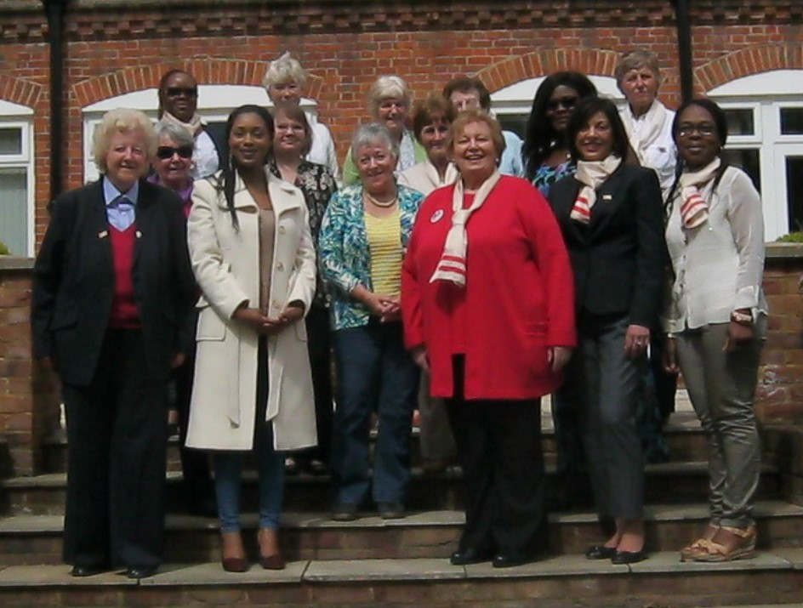

NB. 2016 AGM WILL BE SATURDAY, 16TH APRIL 2016, PROVINCIAL HOUSE, MILL HILL, LONDON NW7 1RE.
UKRAINE – Supported by Bexley Group
We managed to send another 500 euros via a De Paul courier to help finance a programme of summer games and outings - a joy to lighten the worries and circumstances of the seriously at risk children in eastern Ukraine. Concern continues about the armed conflict on their doorstep to the north which seems to be no longer reported in our press. Low flying helicopters frighten rather than excite the children as they are aware they carry seriously injured or dead young soldiers to Kharkiv.

Cynthia continues to fundraise with her crafts, most recently at a fruitful sale at the Bexley parish Film Night. Should you wish contact -cynthiamtjohnson@msn.com

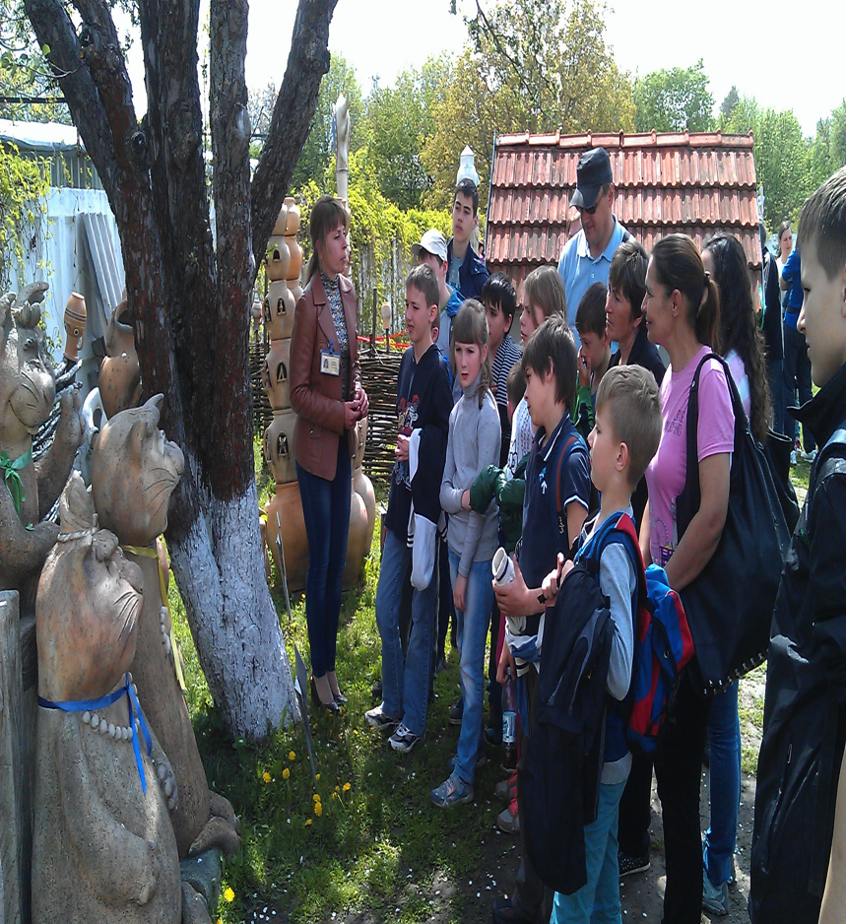

Management Meeting – Warley – 27th June 2015
The newly elected AIC UK Management Committee discussed the results of the consultation on the present state of our organisation. The following was then sent to the new European President, Laurence de la Brosse (former International President):
Report sent to AIC European President 04.08.2015
All Groups were consulted, and the results discussed and collated by the AIC UK Management Committee.
CONSULTATION: What are AIC UK’s strengths, difficulties, priorities and needs.
Feedback from groups had been received and the following was agreed as points to send on.
Strengths; commitment, enthusiasm, persistence, willingness to get involved locally, nationally and internationally, support of the Daughters of Charities and some Congregation of the Mission priests for each group, spiritual input at each meeting, collaborative nature with other organisations, and adaptability (needs led), communications and newsletters.
Difficulties; distance between groups, time limitations, negative profile as being a women’s only group compared to mixed gender Society of St Vincent de Paul (SVP), UK is mixed religiously and culturally. Establishment primarily Protestant and secular. Catholics 10% of population. Recent bad publicity on Catholic Church – regaining some ground because of global popularity of Pope Francis.
Priorities; fulfilment of Vincentian ethos, support for the poor and the modern poverties, collaboration.
Needs; refresh of name and logo (rebranding). Acronym of AIC confusing in English as it should be IAC. No reference to Vincentian or Christian values, symbolism. Acronym sounds like an NGO. Dee put forward a suggestion as perhaps calling ourselves Vincentians In Action, with the I in a shape of a cross. There are records of AIC UK being called The Vincentian Association up until a few years ago.
RESULT OF THE AIC INTERNATIONAL COMPETITION FOR A 2017 LOGO
Well done to our Teresa Gilbey of AIC Bexley who you recall designed the UK entry. All of her ideas, in one form or other, have been incorporated into the final design which is an expansion of an existing logo– see below. Now we begin to consider our own logo and re-branding for AIC UK (see comments in the Consultation above).
All elements of the 400th Anniversary of our foundation in Chatillon les Dombes, France in 1617 are shown in the logo, including a small St Vincent in the central zero of 400.
Part of the 400th Anniversary will be celebrated there – now called Chatillon sur Chalaronne. Do consider joining us on a pilgrimage to the town in East France (near Lyon) during 2017. Details next year
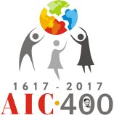
AIC DIPLOMA - > At our Guatemala AIC International Assembly, a number of Latin American association members received AIC Diplomas. 500 had completed this new diploma course in Spanish, initially piloted at the University of Monterey, in order to deepen their understanding of the Vincentian charism and better develop or plan really effective projects that enable poor people to improve their lives.
Plans are now afoot to translate and offer the course in other languages, beginning with English. From September a small pilot group recruited from English speakers worldwide will follow the course with an invitation to become tutors next year. From our country Sr. Mary, Marlene Burt, Dee Mansi and Christine Crump have accepted the challenge. The course will then be offered generally next year. So watch this space for an autumn up-date. Christine is working with the European Team – every blessing to her work.
On a blisteringly hot July evening, I made my way to meet our new vibrant, well organised Group in Peckham. Would it be possible that my welcome could be a warm as a weather – well it was! This is AIC at its best – everyone working well to set up the new Food & Clothes Bank with Café. The flair and hard work of the Group is welcomed by the CM priests and parishioners. Well done!
DEE MEETS AIC PECKHAM – 17.7.2017

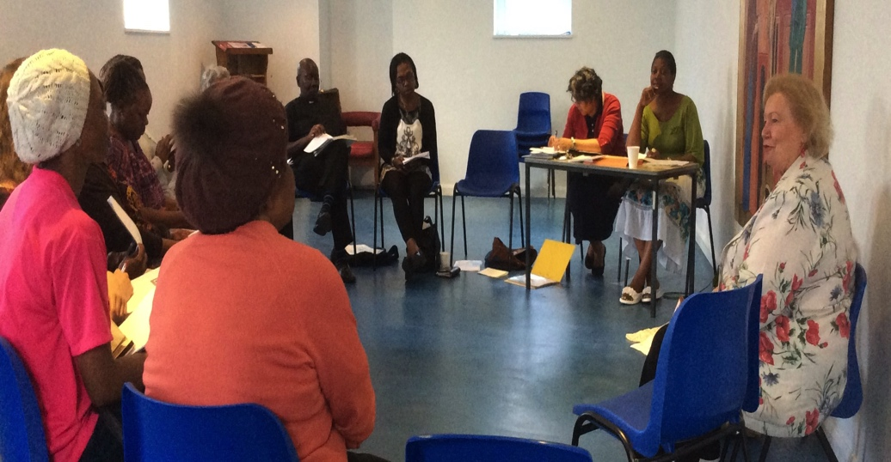

AIC BEXLEY – SATURDAY FRIENDS PROJECT
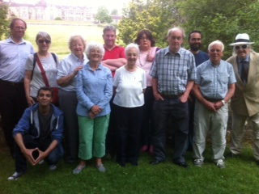
Our July "Saturday Friends" outing to Worth Abbey was well attended. We spent a happy day with Friends from the Passage, Passage House and "Home for Good" who enjoyed a tour of the abbey and grounds with a talk given by Marlene on the history of the buildings and the Benedictine Order. A cold buffet lunch was followed by tea and cakes in the garden.

BARNET VINCENTIAN FAMILY REPRESENTATIVES; Fr Noel Travers CM, Dee Mansi AIC and ViP, Sr Joan Moriarty DC and Eileen Griffin SVP.
VINCENTIANS IN PARTNERSHIP (ViP) – our umbrella Group of Vincentians in the UK. I refer you to the recent ViP Summer Newsletter and ViP Justice Newsletter which gives information on the collaboration with Citizens UK campaign for supporting the re-settlement of Syrian Refugees. A difficult campaign given the public confusion between migrants and refugees, and we are working to persuade each local council to accept 50 genuine refugees fleeing for their lives! Once registered by the United Nations High Commission for Refugees, they are funded to rent housing while they receive the care they need. Marlene’s report after this will illustrate in detail what she has been doing in South London. We have been working similarly in North London – see photo – particularly collaborating with our local Synagogues and other faith groups to achieve this task. Have you got involved?
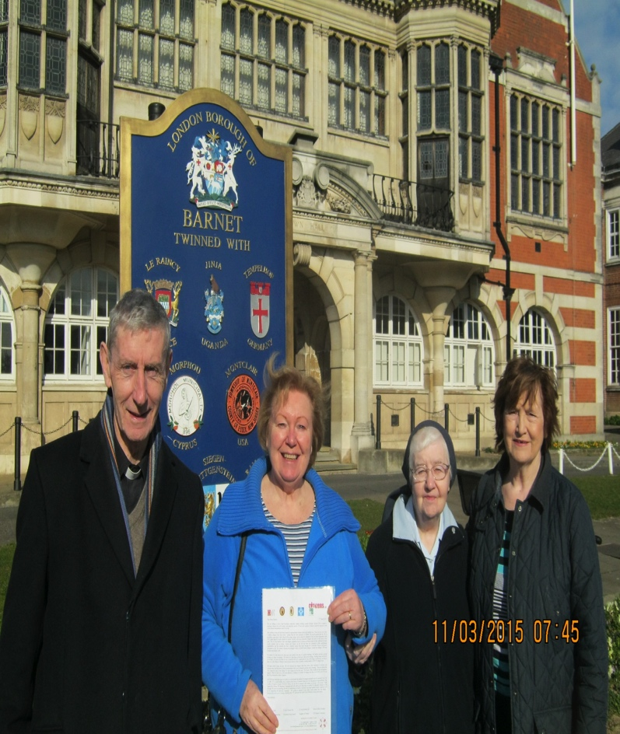

ELSPETH ROBINSON, DARLINGTON AIC – See newspaper article of her Kumi work attached.
MARLENE BURT, AIC BEXLEY – See her comprehensive report of her Justice activity on behalf of AIC and ViP attached.

I hope you are all enjoying the lighter days, meteor showers, mixed weather and warmth of your family and friends.
I send you the Summer Newsletter with all my love and appreciation for the hard work you do voluntarily on behalf of people who need support – which you offer willingly and well.
God bless, Dee Mansi

AIC DARLINGTON SUMMER 2015
AIC Darlington has continued with the regular activities; monthly meetings, fortnightly bingo sessions at ABLE at Catterick, prison visiting at HMP Frankland and YOI Deerbolt and hospice input at St Teresa’s Hospice Darlington.
Helen Jefferson has finally submitted the almost-impossible process of form filling and continues to wait for clearance from the Ministry of Justice. Could she possibly be a terrorist threat? We await their decision month after month.
Elspeth attended the NAOPV (National Association of Prison Visitors) AGM and Conference on 23 June in London. HRH Princess Anne, Patron of the NAOPV association, attended the morning session and spoke of the OPV scheme as a “Force for Good” whose members “go without an agenda and have no issues. They can be a sounding board or a friend to prisoners.” The main speakers were Lord David Ramsbotham of Kensington who is Vice President of the NAOPV and Juliet Lyon CBE, Director of the Prison Reform Trust.
June is always a busy month for AIC Darlington starting with the Kumi Community Open Day to raise funds for the children with disabilities in Kumi Uganda. Over £2,200.00 was raised. Also, in June, AIC Darlington supports the coffees after the Sunday Masses at St Augustine’s Parish Centre and a grand total of £942.15 was banked at the end of the month.
15 July dawned bright for the annual ABLE BBQ in Elspeth’s garden. AIC Darlington members, ABLE carers and adults with learning disabilities, twenty three in all, enjoyed beef burgers, hot dogs and salads, played dominoes and sang not quite in unison and in tune until it was time to bid our farewells.
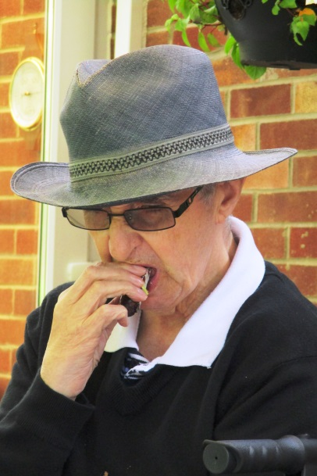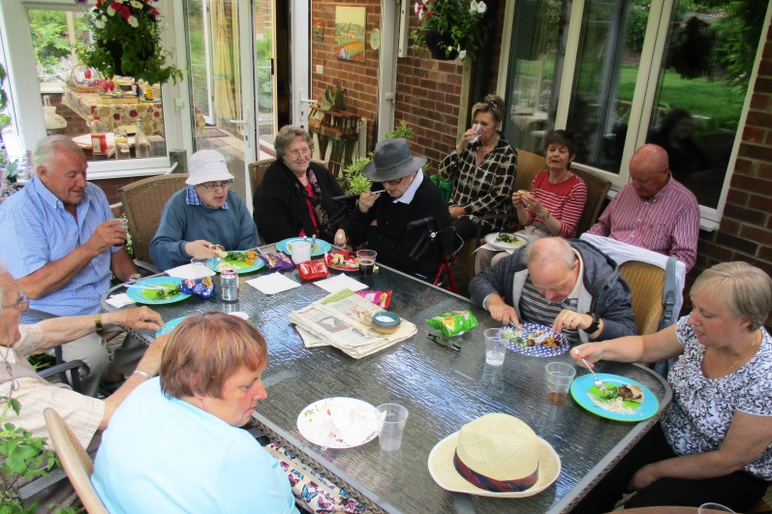
Ian enjoying his food Enjoying an English summer’s lunch in the garden

