Dreams
Sister Rosalie Rendu is recognised for her heroic ministry during the turbulent revolutionary time of 19th century Paris. She spent her entire life working with the poorest and most desperate people. It is surprising then to hear that she feared the judgement of God. Yet we know she confided to Armund de Melun, her first biographer that she had this dream.

“One night I dreamed that I stood at the judgment seat of God. God received me with great severity and was about to pronounce my sentence when, suddenly, I was surrounded by an immense crowd of people carrying old boots, shoes and hats. They presented these things to God saying ‘ She was the one who gave us all these things,’ Then Jesus Christ turned to me and said; because you gave these second hand clothes in my name, I open Heaven to you. Enter for all eternity!”
The terror of the times she lived in is well described in Les Miserables. A victim of the poverty and injustice of the era, Fantine sings a heart breaking song.
I dreamed a dream in time gone by,
When hope was high and life worth living.
I dreamed that love would never die,
I dreamed that God would be forgiving.

Then I was young and unafraid,
And dreams were made and used and wasted.
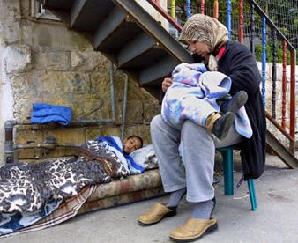
There was no ransom to be paid,
No song unsung, no wine untasted.

I had a dream that life would be,
So different from this hell I’m living.
So different now from what it seemed.
Now life has killed the dream I dreamed.
Reflection
- What are your personal dreams?
- Have you ever experience your dreams being shattered?
  - If so, what helped you at that time?
  - What was not helpful?
- Think about the poorest people in our society. What do you think were their dreams?
- Think about the people you minister to through the AIC. What were their dreams?
- How can we help restore people’s sense of hope?
- Can we help them re-kindle their dreams?
- What dreams do you have as an AIC local group?
- What dreams do you have for the AIC in Britain?

Gods Dream by Charles Peguy
The Lord God said; I myself will dream a dream within you.
Good dreams come from me you know.
My dreams seem impossible,
Not too practical, not for the cautious man or woman;
A little risky sometimes,
A trifle brash perhaps.

Some of my friends prefer to rest more comfortably,
in sounder sleep with visionless eyes.
But for those who share my dreams
I ask a little patience,
a little humour,
some small courage,
And a listening heart- I will do the rest.

Then they will risk and wonder at their daring;
run, and marvel at their speed.
build, and stand in awe
at the beauty of their building.

You will meet me often
as you work in your companions who share in the risk,
in your friends who believe in you enough to lend their own dreams,
their own hands, their own heart, to your building.
In the people who stand in your doorway, stay a while,
And walk away knowing they too can find a dream.

There will be sun filled days and sometimes a little rain-
A little variety, both come from me.
So come now, be content.
It is my dream you dream,
My house you build
My caring you witness;
My love you share,
And this is the heart of the matter.

Concluding Prayer
Loving God, enlighten us as you did Vincent, Louise and Rosalie, so we may see clearly what must be done to make your dream real in a concrete way, in this situation, in this time, through our ministry. Amen.

