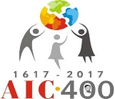 ACTING TOGETHER – AGAINST ALL FORMS OF POVERTY

AIC UK is part of the 150,000 strong International group of, primarily, women whose spirituality is rooted in Vincentian tradition. Begun in 1617 by St Vincent De Paul, the Confraternities of lay volunteers help the disadvantaged in society. Known as Ladies of Charity, this name many countries still use today under the AIC umbrella. Groups in ABBEY WOOD, BEXLEY, DARLINGTON, GLASGOW, MILL HILL & PECKHAM. info@aic-uk.org.uk CONTACT EMAIL linked to our website; aic-uk.org.uk

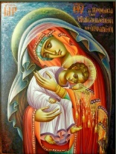
Christmas Reflection: To Jesus through Mary

We are now entering into the third week of Advent, and we will be thinking more deeply of Mary the Mother of Jesus. Finally, on 25th December we celebrate her birthing Jesus into our world and our lives. We can say in truth that we are going to Jesus, through Mary.
- What does this mean in my life?
- How important is this to me?

When we can, let’s take time out to contemplate this wonderful mystery of the birth of Jesus amongst us, through the Fiat of Mary, to the magnanimous gesture of Joseph taking his espoused wife Mary into his life, because he was told in a dream by an angel, that the child within her womb had been conceived by the Holy Spirit.

After her Fiat, her selfless ‘Yes’, Mary’s first thought was of her cousin Elizabeth. She who could not conceive was now expecting a child. As they met each other, Elizabeth cried out in joy that the child in her womb leapt for joy. Mary in return proclaimed her words of joy and praise to God.

Let’s take a few moments now to read these words of the Magnificat… Mary’s song of praise…

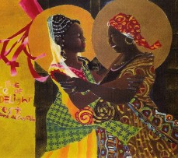
My soul, glorifies the Lord, my spirit rejoices in God my Saviour.
He looks on His servant in her lowliness; henceforth all ages will call me blessed.
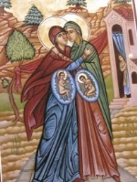
The almighty works marvels for me, holy His name.
His mercy is from age to age, on those who fear him.
He puts forth His arm in strength and scatters the proud hearted.
He casts the mighty from their thrones, and raises the lowly.
He fills the starving with good things, sends the rich away empty.
He protects Israel his servant, remembering his mercy.
The mercy promised to our fathers, to Abraham and his sons forever.

This is Mary – praising God for the wonders he has worked. She is His lowly servant, bearing His Son, Jesus. No pride, no show, just praise of God. How wonderful!

Let us unite in prayer with Mary the Mother of Jesus, our Mother, during these remaining days of Advent and beyond. Entrust to her everything in our lives. Mary, Mother of our Lord and Saviour Jesus Christ, draw us closer to Him during this Advent season, the season of waiting and arrival. May we remember to say often, the little prayer, ‘To Jesus through Mary. Amen’

Wishing each of you and your families, a blessed, holy and happy Christmas.
My love and assurance of prayers, Sister Bernadette, DC

Kumi, UGANDA

Educating the children with disabilities or their siblings continues to dominate our visits. An example of this is Sam Waujuu who has two sisters with severe physical and mental issues. We have educated him through secondary school and university with him graduating in dentistry just this month. He started working as the sole dental officer in Kumi Hospital on 1 December 2018 and now will support his family who live in extreme poverty. My connection with Dentaid enabled him to ate nd their Ugandan mission in October and we will support him to attend their next visit in February. If he achieves a certain standard, they will fund him on future visits enabling him to network with other dentists. Kumi Hospital has been unable to recruit a dentist for a long time as the place is too remote and incomers do not speak the language. Sam fits the bill perfectly and hopefully, for his sake, will one day spread his wings and achieve high goals in dentistry. He is happy, the local people also who now have dental care and I am overjoyed!

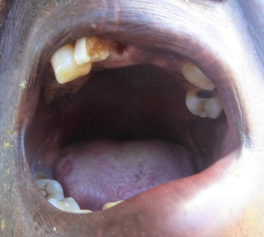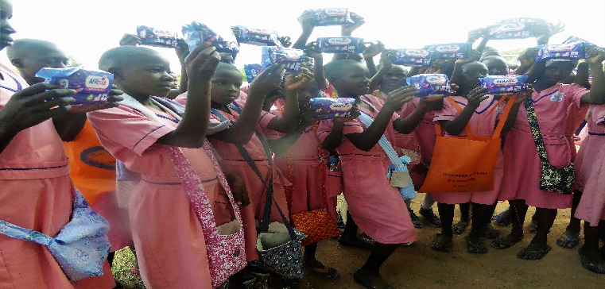

Girls miss out a lot on schooling when they have their periods and so we have provided over 400 with Afripads, reusable sanitary protection made in Uganda. www.afripads.com Many do not have pants so they are given two pairs together with a shoulder bag and a piece of soap. We have also supplied the Kumi Hospital student nurses, our women’s groups and the Kumi Gender Based Violence Shelter (Actionaid). We were given larger pants size 14 and 16 and so we left very happy teachers with their packs also. We fund-raise constantly throughout the year and have collected 300 pants because they are poor quality there.

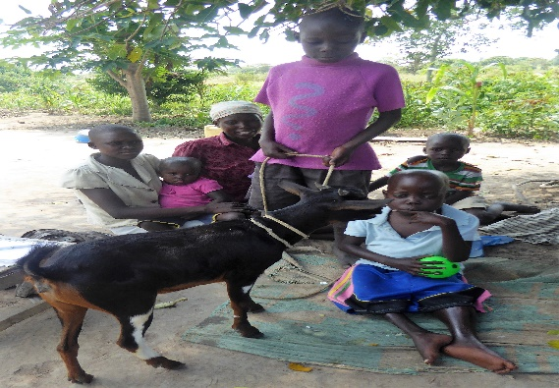
The local primary school volleyball team was the only Ugandan team to be selected to attend a tournament in Rwanda and they came back with the bronze trophies. In the past three years, over thirty of the pupils have been sponsored by good Ugandan secondary schools due to their volleyball skills and without which their future would more than likely be as peasant farmers as the education leaves a lot to be desired. A successful and rewarding visit, my 26th! Elspeth Robinson, AIC Darlington. Founder Kumi.

KIROHO INTERNATIONAL, KENYA. SUPPORTS THE DAUGHTERS OF CHARITY
KIROHO INTERNATIONAL was started 2008 in St Vincent’s School, Mill Hill, London. Since 2013, Kiroho became a separate charity benefitting the Daughters of Charity Missions in Kenya by over £70,000 towards micro-finance projects, the disabled, elderly and hospice care. Most of all, we have tracked and funded many students through Thigio Primary into local Secondary Schools including 4 students through to Third Level Education. It is a miracle that they have survived a very patchy education provision so far! Amazingly, our first graduate Francis, has achieved a BSc from the Kenya Institute of Mass Communication, and is an intern with Kenya TV News! Dee Mansi. AIC Mill Hill. Founder Kiroho
KHARKIV, UKRAINE
In the third of our overseas updates, Cynthia Johnson and Irving her partner, of AIC Bexley, regularly demonstrate their craft and culinary expertise at the Bexley Film Night raising much needed funds for the AIC Ukraine after-school club for neglected children in Kharkiv. Having tasted Cynthia’s jam and marvelled at Irving’s wood turning skills, I am not surprised that I was able to hand over 2,000 Euros in cash to Fr Vitaly Novak via Sr Margaret Barrett.

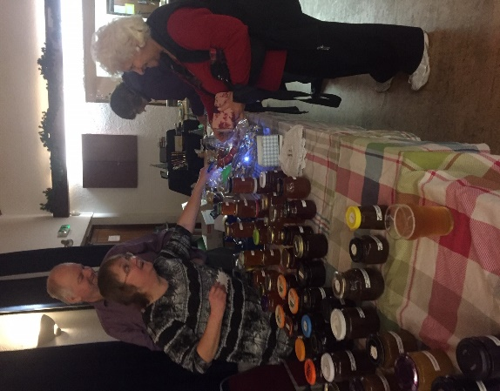
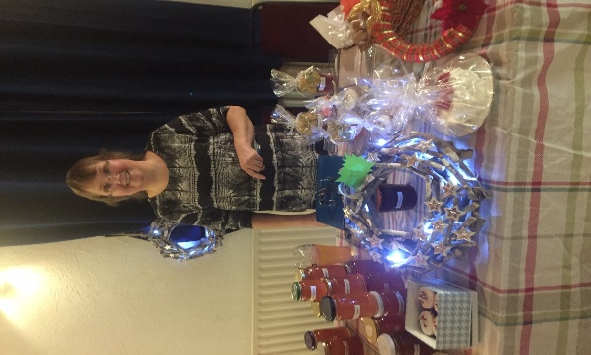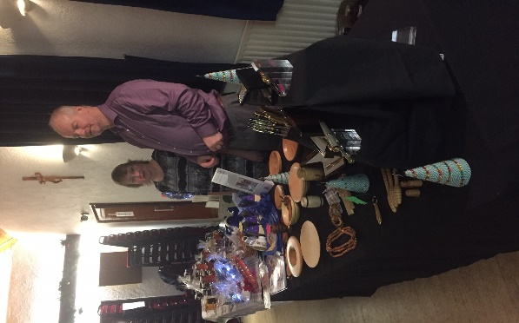
HAVE A HAPPY, HOLY CHRISTMAS AND A HOPEFUL 2019!
LOVE AND BLESSINGS, DEE MANSI. AIC UK PRESIDENT.
